Web Server

when we speak about web server, the Apache Web Server comes at the top. The Apache Web Server is widely used web server in the world to host web sites, 90% of the web sites in the world are running on Apache Web Server.

Name Resolution:
Computers only understantd numaric language that is IP address to reacch computer with in a network. Other hand, human uses computer names to reach computer in network. In order to overcome this problem we need to resolve name to ip and ip to name. This conversion of ip to name and name to ip is called as name resolution.
DNS is a service / server which does this job.
1)Local DNS - /etc/hosts
if you have no DNS server then we need to manually makes an entries of ip and computer names in this file.

2)Global DNS – provided by ISP
Global DNS entries goes to /etc/resolv.conf file. 8.8.8.8 and 4.4.4.4 these are free dns servers provides by any ISP.

We just understand this Name Resolution concept coz we will be making manuall entries in /etc/hosts file in order to make our web server working.

How to find hot name in linux:
#hostname -to find your hostname.

You can give session specific host name with hostname command and with echo command.
Commands goes this way

#hostname new_host_name

below command finds file name where your hostname is stored.

#find /proc/ -name *hostname*

to change session specific hostname with echo command

#echo "any.radical.com" >/proc/sys/kernel/hostname

To Permanently give hostname just edit this config file
/etc/sysconfig/network

Note: change made in this file takes effect after system reboot.
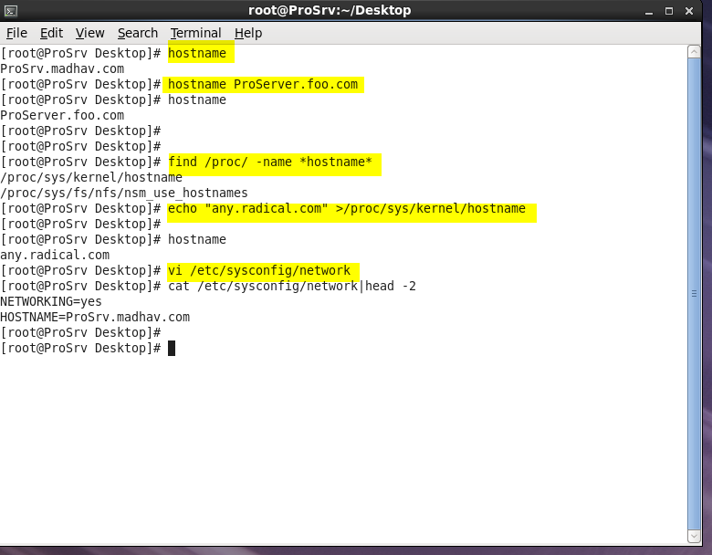

############################################################################|

Name Resolution is Local DNS is done by /etc/hosts file.
After you make these entries restart your network service.
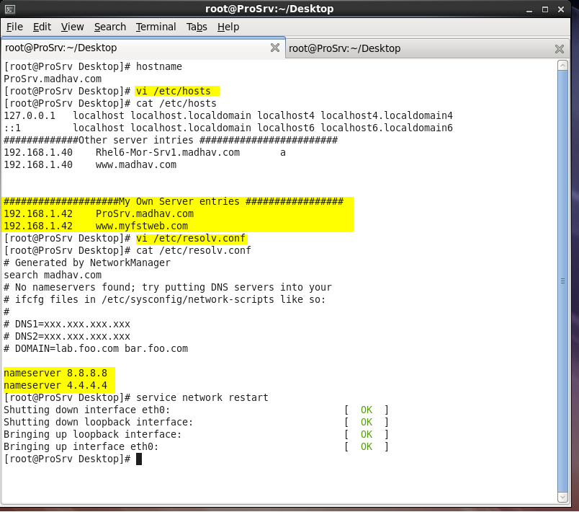

All above was basic requirement to build a web server.

#######################################################################################|

Steps to build Apache Web Server:

- install httpd package.
- Gather information
url or name of your web site, document root, home page (index.html), Error and logs file names, admin of your web server.
- Configure your httpd server. Make changes in /etc/httpd/conf/httpd.conf file.
- Test your httpd server with #httpd -t command.
- Start httpd service
- make httpd service persistant.
- Disable firewall and keep selinux in permissive mode.
- Remote test your httpd server.
- Unable f/w and selinux and write f/w and selinux rules for your httpd server.
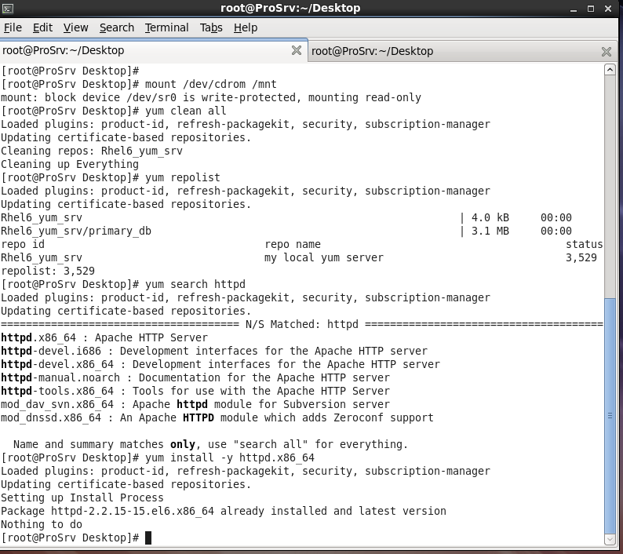

Basic Linux Server comes with httpd pre installed.

#rpm -qc httpd.x86_64 -to find configuration files of httpd server

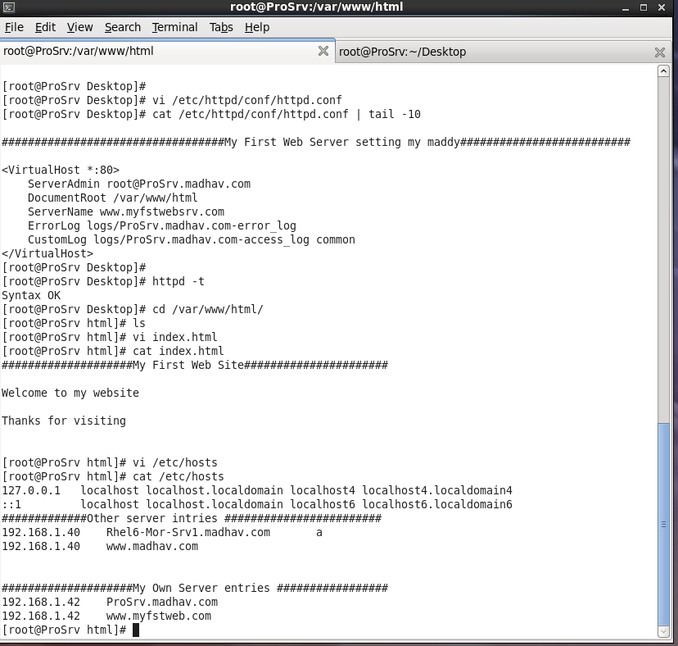
Fig: Step 2 , 3, and 4 SS practicle SS

#httpd -t - is the command to test your server. Syntax OK means no error found all okay.

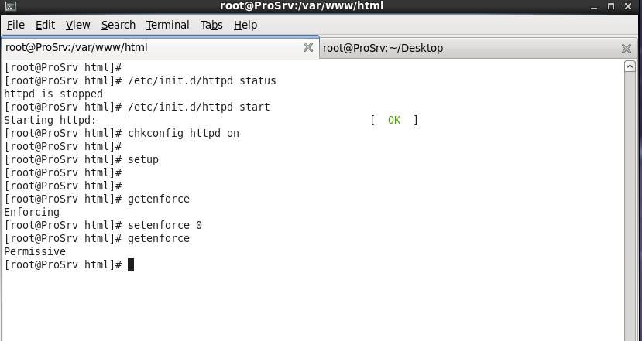
Fig: step 5,6 and 7

step 7: #setup command is used to disable to firewall.

All good Server side work is done.
Go to any client and access your website.

Conditons :
both client and server should be connected to each other.
They should ping each other.

To resolve name to ip make an server ip and name entries in client host file as we have no DNS server.

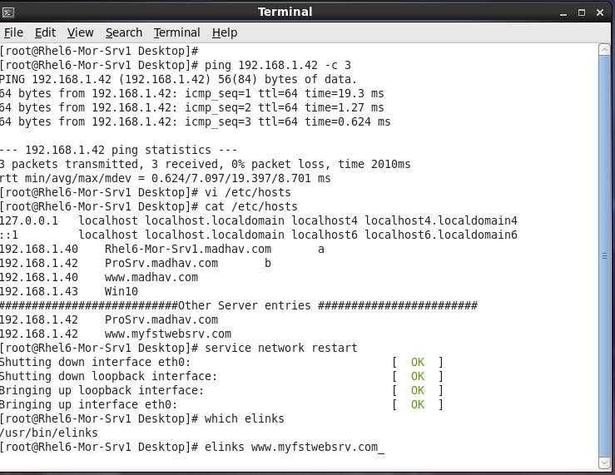

Note: elinks is a cli web browser

